Target of Myb protein1 (Tom1), is a gene involved in the ribosomal biogenesis in yeast and human respectively. In human, this gene is involved in several pathways including endocytosis1, endosomal transport1, intracellular protein transport1, neutrophil degranulation1 and protein transport2. In human it’s located on the ch.22 (component UP000005640) and ch.4 in human and yeast respectively. As it’s well conserved among the eukaryote, we can study the gene with yeast foe the raisons explained above. In yeast specifically, TOM1 was first described as gene involved in temperature sensitivity and could be supress by STM13. TOM1 is a hect-domain, wherein has been identified as a conserved feature of E3 ubiquitin ligases group4. It regulates transcriptional activation Through effectors ADA on coactivator proteins on the DNA. The action of TOM1 is to regulate through ubiquitination the temperature sensitivity4. A tom1-1 mutant has been isolated, and under electron microscopy and indirect immunofluorescence microscopy, it has been shown that the large nucleus contains duplicated DNA and short spindle and structures fragmentations.5. This show that the disruption of the system that impact the nuclear transport and the cell division in the G1 phase2,5. TOM1 encode for a large 380KDa proteins with a hect-domain at its C terminus (homologous to E6-AO C terminus)5. Site-directed mutagenesis of the conserved cysteine residue (tom1C3235A) in the hect-domain, supposed to be necessary for thioester-bond formation with ubiquitin, abolished the gene function5. After a test with the over production of a myc-tagged ubiquitinRA, it shows that TOM1 is a ubiquitin ligase5.

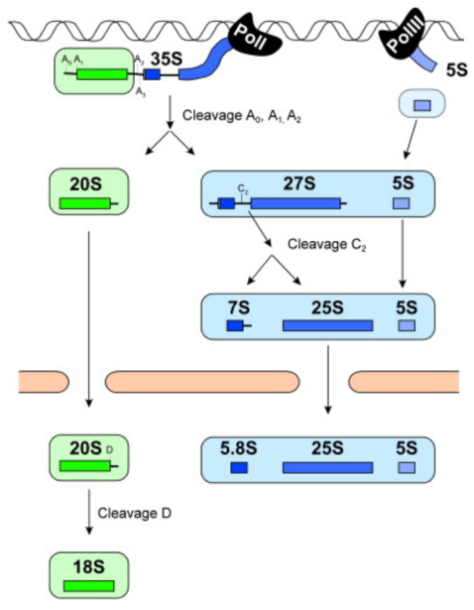More recently, TOM1 has been described as a fundamental macromolecular machine. The ribosomes biogenesis is much more complex in eukaryote cells as in bacteria, and it’s involved in several fundamental cellular processes, including growth and cell division7. Ribosomes are subunits assemblage allowing the production of proteins. Subunits are made of RNA (rRNA) and specifies proteins (r-proteins) (Saccharomyces cerevisiae: 40S [18S rRNA, 33 RPs]; 60S [25S, 5.8S, 5S rRNA, 46 RPs]–Escherichia coli: 30S [16S rRNA, 21 RPs]; 50S [23S, 5S rRNA, 34 RPs])10. Recent studies have shown that defect in the biogenesis linked to a wide range of hereditary diseases like Alzheimer’s and anemia9,11. Ribosomes are a mixture of almost 80 different protein and stick together through a scaffold made by the RNA as explain above. Each protein is express in one copy and each of these proteins are needed to assemble the ribosomes. However, the number of steps needed for the biogenesis is large and not totally known. Moreover, it’s impossible for a cell to produce the exact number of the needed proteins, furthermore the same number of copies of all the proteins in a ribsome8. It will build up the number needed and then degrade the leftover, wherein are ubiquinined by TOM1 and degraded in lysosomes. We can say that TOM1 act as a quality control on this mechanism during the anabolism and division phases of the cells, leading to a week and crucial homeostasis8. Ribosome biogenesis is an intricate process involving many chaperons and assembly factors (>200 factors) and snoRNAs (75)10. Two subunits are part of the final ribosomes, the 40S has one rRNA (18S) and 33 r-proteins. The 60S (comprises three rRNAs (25S, 5.8S, 5S) and 47 r-proteins subunit9,10. The assembly and maturation of the ribosomes passes from the nucleus to the cytosol. , ATP-dependent RNA helicases and three AAA-type ATPases (ATPases associated with various cellular activities). This suggests that the energy derived by these enzymes is required for ribosomes assembly. The absence of one of these proteins might stall ribosome biogenesis and terminate cell growth even under optimal growth conditions 7,10. To summarize, TOM1 is necessary to the ribosome’s biogenesis and the elimination of the leftover building blocks by ubiquitination. Thus, the aim of this project is to identify the suppressor of this gene by high sequencing throughput with bioinformatics tools.

Figure 1: Simplified overview of the major steps in pre-rRNA processing.

**1)"TOM1 genes map to human chromosome 22q13.1 and mouse chromosome 8C1 and encode proteins similar to the endosomal proteins HGS and STAM."**  
[Seroussi E.](https://www.uniprot.org/uniprot/?query=author:%22Seroussi+E.%22&sort=score), [Kedra D.](https://www.uniprot.org/uniprot/?query=author:%22Kedra+D.%22&sort=score), [Kost-Alimova M.](https://www.uniprot.org/uniprot/?query=author:%22Kost-Alimova+M.%22&sort=score), [Sandberg-Nordqvist A.-C.](https://www.uniprot.org/uniprot/?query=author:%22Sandberg-Nordqvist+A.-C.%22&sort=score), [Fransson I.](https://www.uniprot.org/uniprot/?query=author:%22Fransson+I.%22&sort=score), [Jacobs J.F.M.](https://www.uniprot.org/uniprot/?query=author:%22Jacobs+J.F.M.%22&sort=score), [Fu Y.](https://www.uniprot.org/uniprot/?query=author:%22Fu+Y.%22&sort=score), [Pan H.-Q.](https://www.uniprot.org/uniprot/?query=author:%22Pan+H.-Q.%22&sort=score), [Roe B.A.](https://www.uniprot.org/uniprot/?query=author:%22Roe+B.A.%22&sort=score), [Imreh S.](https://www.uniprot.org/uniprot/?query=author:%22Imreh+S.%22&sort=score), [Dumanski J.P.](https://www.uniprot.org/uniprot/?query=author:%22Dumanski+J.P.%22&sort=score)  
[Genomics 57:380-388(1999)](http://dx.doi.org/10.1006/geno.1998.5739) [[PubMed](https://www.ncbi.nlm.nih.gov/pubmed/10329004)] [[Europe PMC](https://europepmc.org/abstract/MED/10329004)] [[Abstract](https://www.uniprot.org/citations/10329004)]

2) **"Endofin recruits TOM1 to endosomes."**  
[Seet L.-F.](https://www.uniprot.org/uniprot/?query=author:%22Seet+L.-F.%22&sort=score), [Liu N.](https://www.uniprot.org/uniprot/?query=author:%22Liu+N.%22&sort=score), [Hanson B.J.](https://www.uniprot.org/uniprot/?query=author:%22Hanson+B.J.%22&sort=score), [Hong W.](https://www.uniprot.org/uniprot/?query=author:%22Hong+W.%22&sort=score)  
[J. Biol. Chem. 279:4670-4679(2004)](http://dx.doi.org/10.1074/jbc.m311228200) [[PubMed](https://www.ncbi.nlm.nih.gov/pubmed/14613930)] [[Europe PMC](https://europepmc.org/abstract/MED/14613930)] [[Abstract](https://www.uniprot.org/citations/14613930)]

## 3)  Utsugi T, et al. (1995) A high dose of the STM1 gene suppresses the temperature sensitivity of the tom1 and htr1 mutants in Saccharomyces cerevisiae. Biochim Biophys Acta 1263(3):285-8

4) Saleh A, et al. (1998) TOM1p, a yeast hect-domain protein which mediates transcriptional regulation through the ADA/SAGA coactivator complexes. J Mol Biol 282(5):933-46

5) Utsugi T, et al. (1999) Yeast tom1 mutant exhibits pleiotropic defects in nuclear division, maintenance of nuclear structure and nucleocytoplasmic transport at high temperatures.

6) Kim DH and Koepp DM (2012) Hect E3 ubiquitin ligase Tom1 controls Dia2 degradation during the cell cycle. (concerne la lsentitivité de TOM1🡪 a intégrer plus tard)

7) Dinman JD. The eukaryotic ribosome: current status and challenges. *J Biol Chem*. 2009;284(18):11761–11765. doi:10.1074/jbc.R800074200

8) Sung MK, Porras-Yakushi TR, Reitsma JM, et al. A conserved quality-control pathway that mediates degradation of unassembled ribosomal proteins. *Elife*. 2016;5:e19105. Published 2016 Aug 23. doi:10.7554/eLife.19105

9) example report 2014 BC_7107_19

10) Biochim Biophys Acta. 2010 Jun;1803(6):673-83. doi: 10.1016/j.bbamcr.2009.10.009. Epub 2009 Oct 30.

Driving ribosome assembly.

Kressler D1, Hurt E, Bassler J.

11) J Neurol Sci. 2016 Jun 15;365:101-7. doi: 10.1016/j.jns.2016.03.035. Epub 2016 Apr 13.

Immunolocalization of Tom1 in relation to protein degradation systems in Alzheimer's disease.

Makioka K1, Yamazaki T2, Takatama M3, Ikeda M4, Murayama S5, Okamoto K3, Ikeda Y4.